**IST471**

**Lab 5 (45 points)**

**SQL Analytic Functions – Windowing**

*Note: Before beginning the following were inserted…*

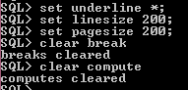

1. **(10 points) Create an analytic query to identify the following payroll figures:**
2. SUM_BEFORE: the sum of salary values before the current row
3. SUM_AFTER: the sum of salary values after the current row
4. AVG_BEFORE: the average of salary values before the current row
5. AVG_AFTER: the average of salary values after the current row
6. MAX_BEFORE: the highest salary value before the current row
7. MAX_AFTER: the highest salary value after the current row
8. MIN_BEFORE: the lowest salary value before the current row
9. MIN_AFTER: the lowest salary value after the current row

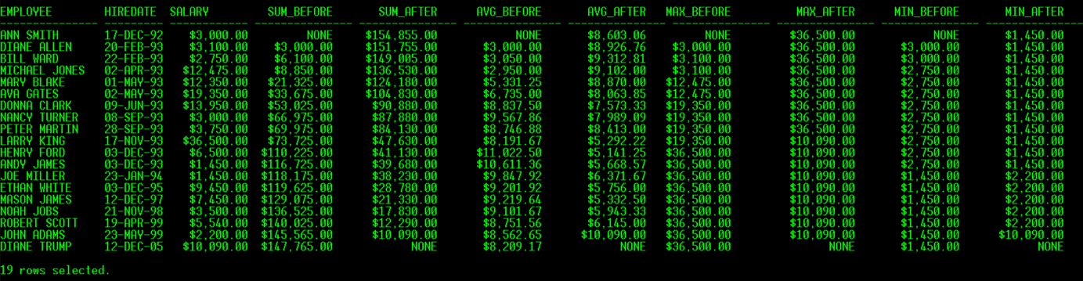

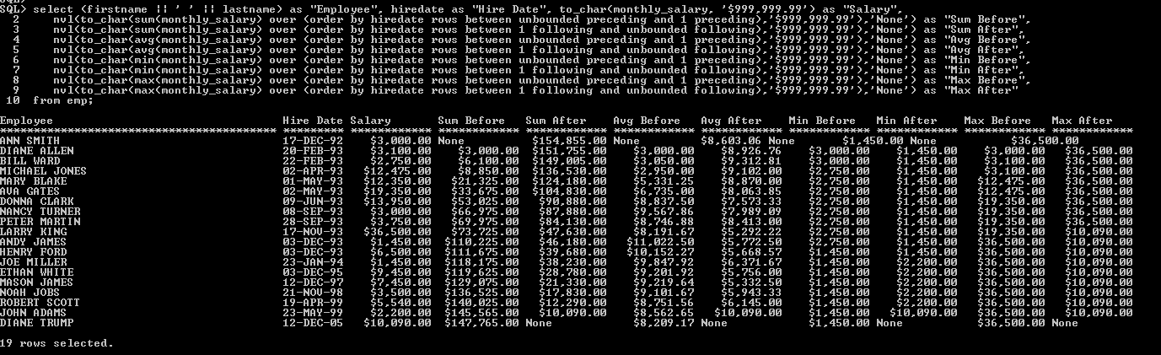

1. **(10 points) Create an analytic query to compute the following sums of salaries:**

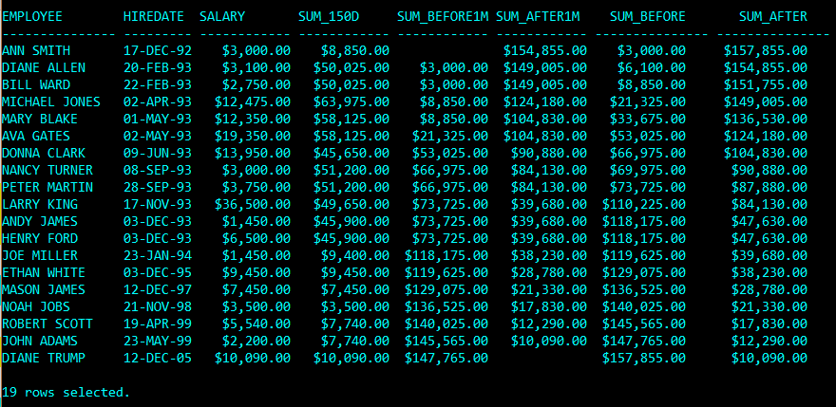

1. SUM_150D: the sum of salaries paid two months before and three months after the current row
2. SUM_BEFORE1M: the sum of salaries paid 1 month before the current row
3. SUM_AFTER1M: the sum of salaries paid 1 month after the current row
4. SUM_BEFORE: the sum of salaries paid before the current row
5. SUM_AFTER: the sum of salaries paid after the current row

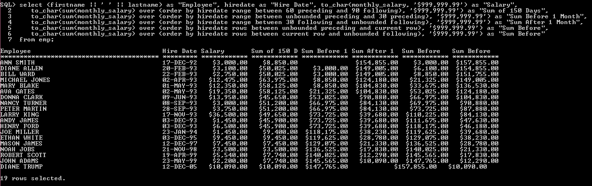

1. **(10 points) Create an analytic query to computer various sums of sales partitioned by the order dates. The output should include the following data:**
2. Order date
3. Order#
4. Sales of each order. Sales = SUM(paideach*quantity)
5. SUM_SALES1: running sum of sales for each order date
6. SUM_SALES2: reverse running sum of sales for each order date
7. SUM_SALES3: sum of all sales on each order date
8. MEAN_SALES: mean sales on each order date
9. MEDIAN_SALES

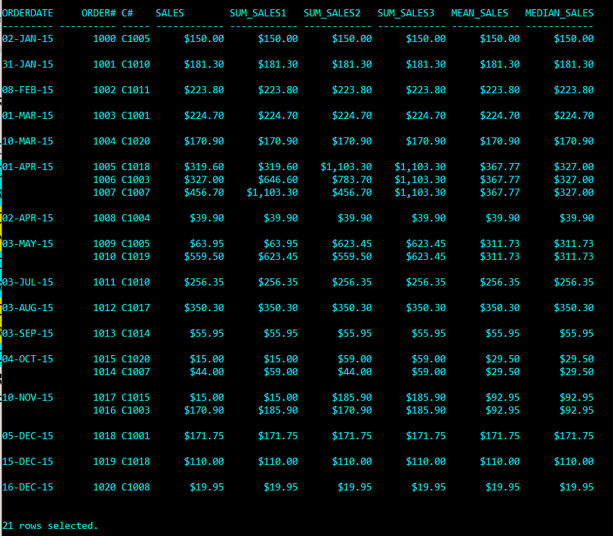

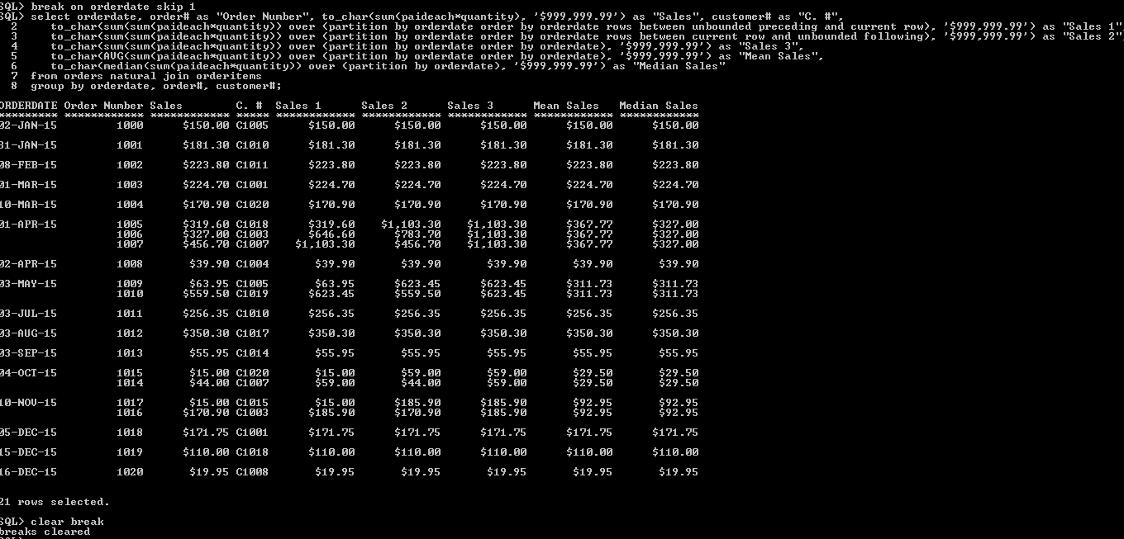

1. **(15 points) First load the dataset, "Exam_Scores.sql" to your SQL program.**

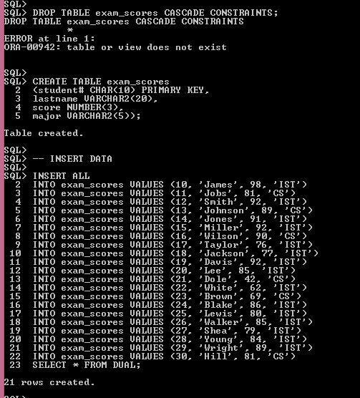

**There are 15 IST students and 3 CS students taking the exam for Data Analytics Competitive. Compute the "3M" measures (i.e.,mean, median, and mode) based on their exam scores.**

* 1. **Create a query to list each student's score and compare each score with the mean and median for each major of students.**

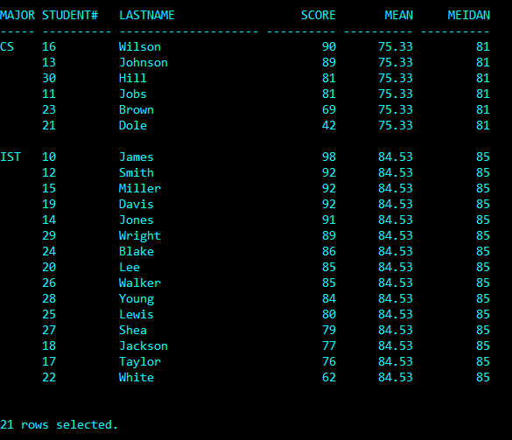

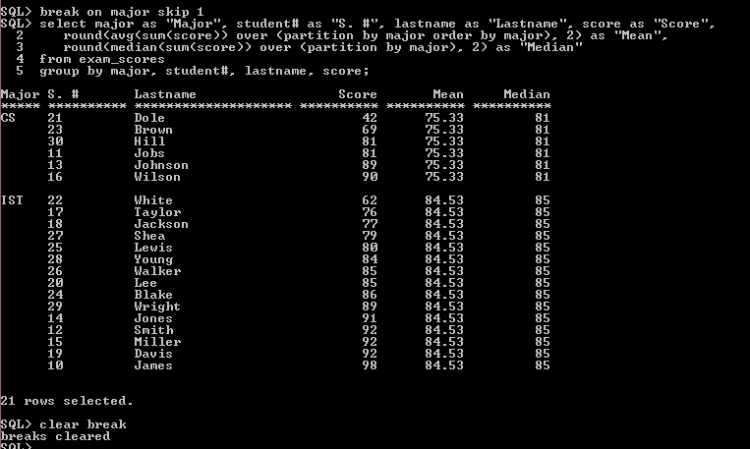

* 1. **Figure out the mode of exam scores, one for each major**

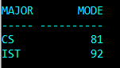

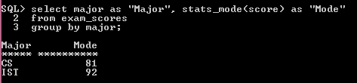

**4.3 Add a new record for another IST student (#31, Gates). His score is 85. Now you have two modes for IST. Write a query to display these two modes shown as below:**

